Week 10 reflection:

Briefly answer Q 1-5 in your diary entry about your project. You can change them as you refine your idea. Report the errors and challenges you are facing.

1. What is your project about? (A 1-2 word answer that describes your main focus, e.g., climate change)

Social pressures surrounding beauty

1. What is the data you plan to use? (A link to the dataset with one sentence describing it)

[This](https://digitaluniversity.womendeliver.org/wp-content/uploads/2020/05/Mod-1-2017-Dove-Global-Girls-Beauty-and-Confidence-Report.pdf) dataset was a survey commissioned by Dove in 2017, with a possibility of comparing with other [surveys](https://www.clubofamsterdam.com/contentarticles/52%20Beauty/dove_white_paper_final.pdf) conducted previously to provide a time comparison.

1. What is the question you plan to answer? (One sentence that ends with a question mark that could act like the title of your data story)

How do pressures surrounding beauty impact women in terms of social and financial costs?

1. Why is this an important question? (Three sentences, each of which has some evidence, e.g., “According to the United Nations...” to justify why the question you have chosen is important)

Investigating the financial and non-financial costs of beauty pressures is important, given the costs are borne by both individuals and society - in the US alone, “body dissatisfaction incurs $84 billion in financial costs, with an additional $221 billion in loss of well-being… appearance-based discrimination incurs $269 billion” every year (Austin et al, 2022). For example, financial costs have been incurred from loss in economic efficiency as society needs to provide more healthcare to meet increased treatment needs of conditions to do with body dissatisfaction or discrimination (Austin et al, 2022).

Furthermore, the heavy social and non-financial costs crucially impact girls’ and young women’s well-being worldwide; girls who are unhappy with their bodies because they do not live up to the social pressures of beauty standards are more likely to engage in higher levels of disordered eating, such as dieting, and unhealthy weight control (Neumark-Sztainer et al, 2006), as well as suffer from depressive moods and other emotional issues like low self-esteem (Paxton et al, 2006).

1. Which rows and columns of the dataset do you plan to use, to answer this question? (Actual names of the values you plan to filter (rows) or subset (columns) the data on)

For Chart 1, using data from [this](https://digitaluniversity.womendeliver.org/wp-content/uploads/2020/05/Mod-1-2017-Dove-Global-Girls-Beauty-and-Confidence-Report.pdf) dataset, I used lowSE, medSE, and highSE to represent percentages of girls with low, medium, and high self-esteem who reported feelings of pressure to be beautiful.

For Chart 2, using data from [this](https://www.hsph.harvard.edu/striped/wp-content/uploads/sites/1267/2022/10/Real-Cost-of-Beauty-Report-10-4-22.pdf) dataset, I used ‘non-financial cost’ and ‘financial cost’ to represent the amount (in USD billions) lost from body dissatisfaction in the US.

Errors:

* When my Github page first loads, elements on the page overlap and the charts are larger than I coded them to be.

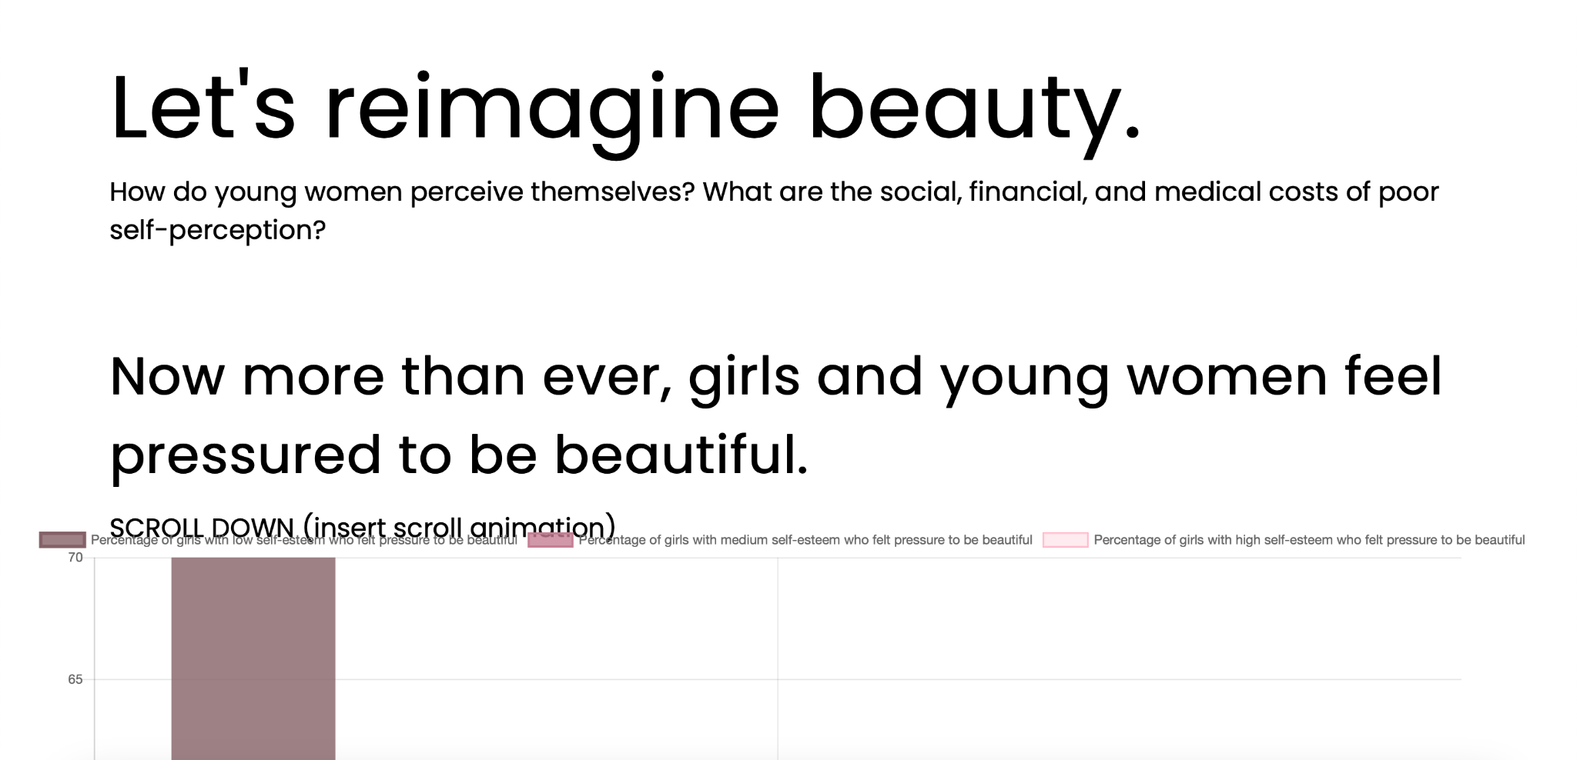

However, on refresh, the error resolves itself (see below) - still not sure why this happens.

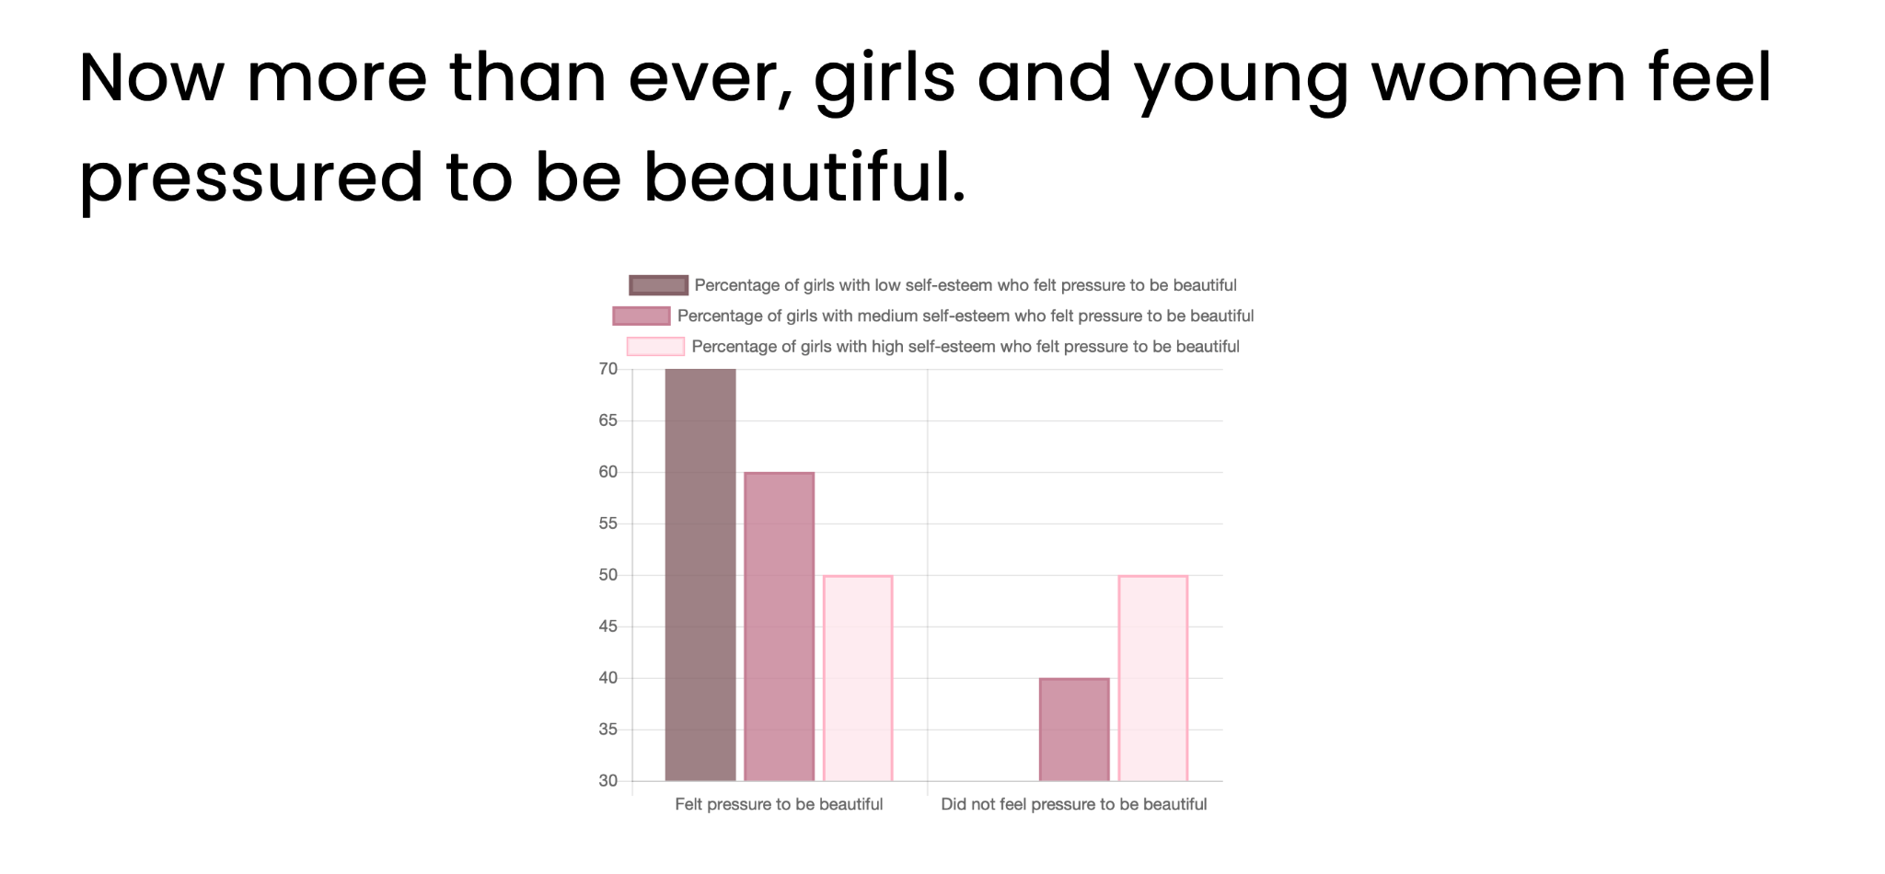

Challenges:

* The research question and topic in general is quite nebulous and I think both need several rounds of refinement for me to get at what exactly I need to cover in my data story.
* Time management - it has been hard to find time to work on this project outside of class work.